**GENERAL HUMAN BIOLOGY – YEAR 12**

**TASK 3 – SKELETAL SYSTEM TEST**

***MULTIPLE CHOICE SECTION [5 MARKS]***

|  |  |  |  |
| --- | --- | --- | --- |
| **1.** | C | **4.** | C |
| **2.** | B | **5.** | A |
| **3.** | C |

***SHORT ANSWER SECTION [32 MARKS]***

1. Look at the human skeleton, identify the following bones: [3 marks]

* Based on locations selected on day by teacher
* 1 mark per correct bone -> 3 in total

1. The ends of bones in a joint never touch. If they did, moving would be very painful. What fluid in the joint helps keep the bones from touching? [1 mark]

* Synovial Fluid

1. The body has several different types of joints, each with specific features and functions:

Complete the following table as a summary of comparison of the joint types shown above:

[10 marks]

[ ½ mark for each joint type and ½ mark for each bones in joint box filled correctly and 1 mark for one movement produced TOTAL = 10 marks]

|  |  |  |  |
| --- | --- | --- | --- |
| **LOCATION** | **JOINT TYPE** | **BONES IN JOINT** | **ONE MOVEMENT PRODUCED** |
| Elbow | Hinge | Ulna  Radius  Humerus | Flexion/  Extension |
| Shoulder | Ball and Socket | Humerus  Scapula  *Accept if the say clavicle* | Circumduction /  Flexion/  Extension/  Adduction/  Abduction |
| Wrist | Gliding | Carpals | Surface moving over another without any rotary / angular motion |
| Base of thumb | Saddle | Phalanges  Metacarpals | Flexion/  Extension/  Adduction/  Abduction/  Circumduction  But no axial rotation |
| Neck | Pivot | Atlas  Axis | One bone rotates around another – rotation of head |

1. The diagram below shows a joint in the human body. Name the structure and state the function of the structures indicated. [6 marks]

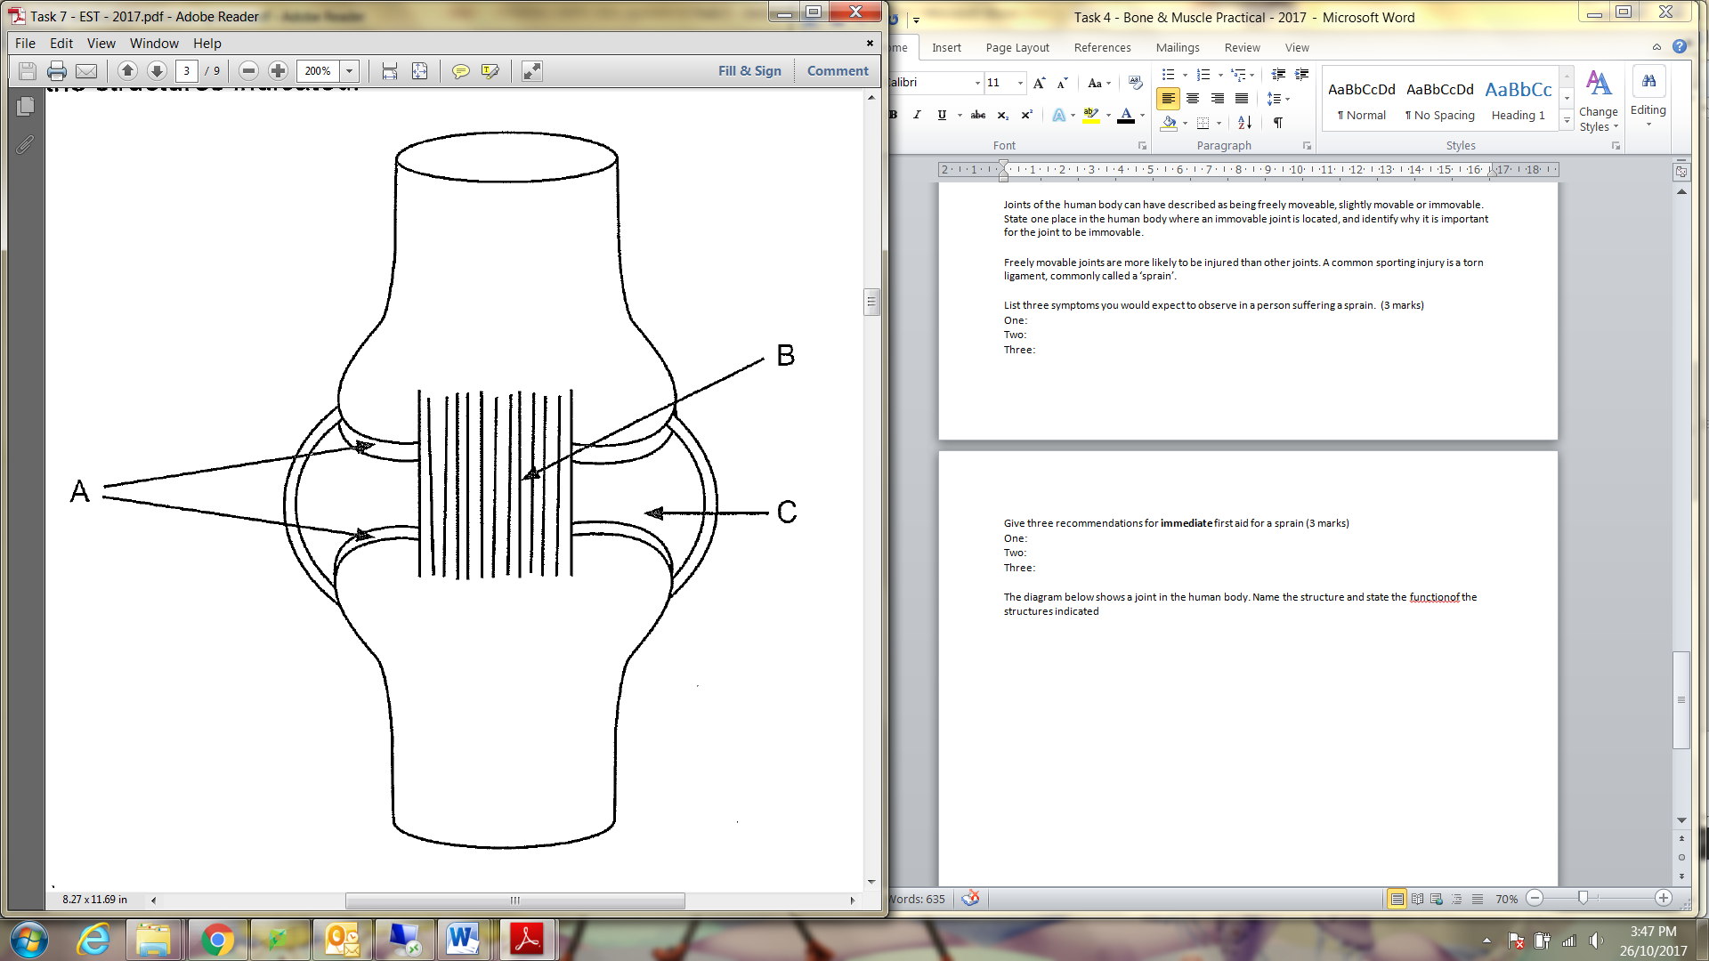

|  |  |
| --- | --- |
| **Description** | **Mark** |
| Name (1) and Function (1) |  |
| A: articular cartilage / cartilage, prevents friction / smooth movement/ protects epiphyses | 1-2 |
| B: ligament, attaches bone to bone / joint movement / holds joint together | 1-2 |
| C: cavity with synovial fluid / synovial fluid / cavity, cushions against impact / reduces friction / nutrients / cells clean out joint | 1-2 |

1. Cartilage is a type of connective tissue found in the human body, usually between or at the end of long bones.
   1. Damage at a joint can result in injury to muscle, bone and cartilage. Explain why the cartilage at a damaged joint would take longer to heal than the muscle or bone. [2 marks]

Cartilage lacks blood vessels and nerves (1)

They rely on nutrients and wastes to be diffused from/to the surrounding tissue/fluid (1)

* 1. If a bone is broken, osteoclasts and osteoblasts play an important role in its repair. Identify the role of each of these cells in bone repair (2 marks)
* Osteoclast: break down bone for remodelling / breakdown bone matrix (1)
* Osteoblast: secretes minerals making up bone and bone matrix / create new bone / build and repair (1)

1. Joints of the human body can have described as being freely moveable, slightly movable or immovable.
   1. State one place in the human body where an immovable joint is located, and identify why it is important for the joint to be immovable. (2 marks)

|  |  |
| --- | --- |
| **Description** | **Mark** |
| Location (1) and Importance (1)  Any correct, examples include: |  |
| * Joints between skull bones / cranium, protects the brain * Joints in sacrum / coccyx, weight bearing * Joint of teeth and mandible, chewing / grinding | 1-2 |

* 1. Freely movable joints are more likely to be injured than other joints. A common sporting injury is a torn ligament, commonly called a ‘sprain’. List three symptoms you would expect to observe in a person suffering a sprain. (3 marks)

|  |  |
| --- | --- |
| **Description** | **Mark** |
| Any three: |  |
| * Pain * Swelling / inflammation / heat * Stiffness * Reduced range of movement * Bruising | 1-3 |

* 1. Give three recommendations for **immediate**first aid for a sprain (3 marks)

|  |  |
| --- | --- |
| **Description** | **Mark** |
| Answers could include: |  |
| * Stop exercise and rest the injured area / remove weight * Use of icepacks * Compress / bandage / strap * Elevate the injured area about heart height * Acronym – RICE = (1 ONLY) | 1-3 |

***EXTENDED RESPONSE SECTION [10 MARKS]***

1. Children have layers of special cell in their bones called ‘growth plates’ or ‘epiphyseal plates’. Describe how a child’s long bone develops to form a mature bone (6 marks)

|  |  |
| --- | --- |
| **Description** | **Mark** |
| **In utero**   * Skeleton made up of hyaline cartilage * Primary ossification site * Centre of the diaphysis begins to calcify / cartilage cells calcify and surrounding cells disintegrate * Cells then ossify when osteoblasts enter the site * Cartilage replaced by bone moving out from primary ossification site * Secondary ossification sites develop in epiphyses of bone | 4 = all 6 points  3 = 4-5 points  2 = 3 points  1 = 2 points  0 = 1 or 0 points |
| **Child**   * Bone grows in length due to the epiphyseal plate that forms between the diaphysis and epiphysis | 1 |
| **Adult**   * The older a person gets, the more of the epiphyseal plate that hardens * Till the epiphyseal line forms | 1 |

1. A healthy lifestyle is essential during childhood and adolescence to build and maintain healthy bones. Explain why a diet with milk or dairy products and sensible sun exposure are important for improving bone health in children (4 marks)

|  |  |
| --- | --- |
| **Description** | **Mark** |
| **Milk and dairy products**   * Provides calcium * Builds the matrix that gives strengths | 1-2 |
| **Sensible sun exposure**   * UV radiation / sun causes / stimulates formation of vitamin D * Vitamin D increases the body’s ability to absorb calcium for bone growth and development | 1-2 |

***END OF TEST***